Ulric Aird

Data Security and Concepts

**Lab 1 Assignment**

**NB**: Most of this lab was done using Virtual Box since my operating system is currently Linux. So most of the stuff like Microsoft Sandbox couldn’t work.

Lab 1-2

Here is after I install Microsoft Security Scanner and attempting to run the scanner.

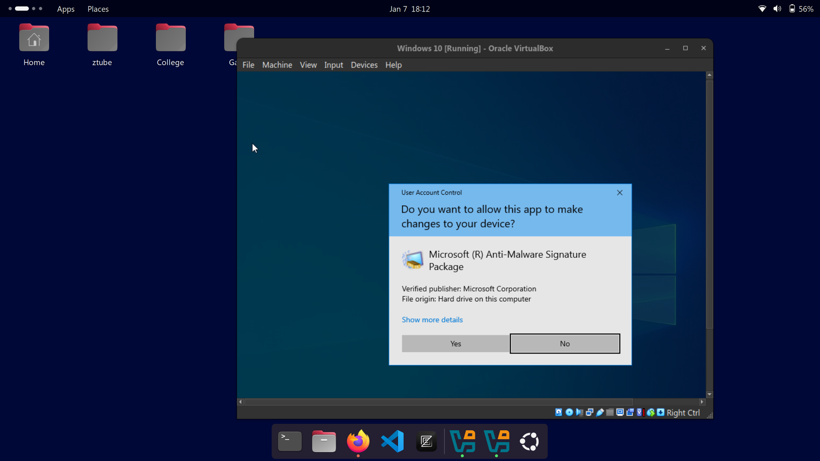

This is the process of running the Scanner

